**Supplementary materials for Martin et al 2015 - Stand dieback and collapse in a temperate forest and its impact on forest structure and biodiversity**

Methods for calculation of climatic water deficit following Lutz et al. (2010).

Monthly precipitation, *Pm*, is divided into a monthly rain fraction (*RAINm*) and a monthly snow fraction (*SNOWm*) for each month by the monthly melt factor *Fm*:

*Ta* ≤ 0°C: *Fm* = 0 [1]

0°C < *Ta* < 6°C: *Fm* = 0.167 × *Ta*[2]

*Ta* ≥ 6°C: *Fm* = 1 [3]

where *Ta* is the mean monthly temperature. Thus,

*RAINm = Fm × Pm*[4]

*SNOWm* = (1 – *Fm*) *× Pm* [5]

The melt factor *Fm* is alsoused to determine the monthly snowmelt, *MELTm*:

*MELTm = Fm* × (*SNOWm* + *PACKm-1*) [6]

where snow pack for a given month, *PACKm*, is given by:

*PACKm* = (1 – *Fm*)2 × *Pm*+ (1 – *Fm*) × *PACKm-1* [7]

The monthly water input (or supply) to the system is then:

*Wm = RAINm + MELTm* [8]

When water input exceeds potential evapotranspiration (*Wm – PETm* ≥ 0), evapotranspiration proceeds at the potential rate and the excess recharges the soil water. If the soil is already at its water-holding capacity, soil moisture remains constant and the excess water is runoff. PET is given by:

 [9]

where *Days* is the number of days in the month, *DL* is the average day length for the month, and *ea(Ta)* is the saturation vapour pressure at the mean temperature *Ta*. The value of *ea(Ta)* is given by:

 [10]

The length of the day, *DL*, in hours, is taken from Dingman (2002) and is given by:

 [11]

where *δm* is the solar declination angle at noon on the 15th day of the month, *Λ* is latitude, and *ω* is the angular velocity of the Earth’s rotation (0.2618 radian hr-1).

Soil water balance is given by:

*SOILm* = minimum{*SOILmax*, [(*Wm* – *PETm*) + *SOILm-1*]} [12]

where *SOILmax* is the soil water-holding capacity in the top 200 cm of the soil profile. In the case of our study site we calculated this by determining the percentage clay, silt and sand in soils at the site and using the methods of Metherell (1993) to produce estimates of soild water-holding capacity for the top 30cm of soil. This was then extrapolated to the top 200 cm of the soil profile.

When PET is greater than water input (Wm < PETm), evapotranspiration equals the water input plus a fraction removed from soil water storage. The fraction removed from soil water storage is given by:

 [13]

Actual evapotranspiration (AETm) then equals the smaller of PETm or (ΔSOIL*+* Wm).

Deficit isthe difference between PETm and AETm.

We used the *Heat Load Index* (McCune & Keon, 2002), reproduced here.

*Af = | 180 – |aspect – 225| |* [14]

*HL = 0.339 + 0.808[cos(L) × cos(S)]*

*– 0.196[ sin(L) × sin(S)] – 0.482[ cos(Af) × sin(S)]* [15]

where *L* is latitude, *S* is slope, and *Af* is folded aspect.

The heat load index was applied as a multiplier of the PET term in the water balance equations, similar to the method used by Stephenson (1998). This modification of Eq. 9 yields a final equation for PET:

 [16]

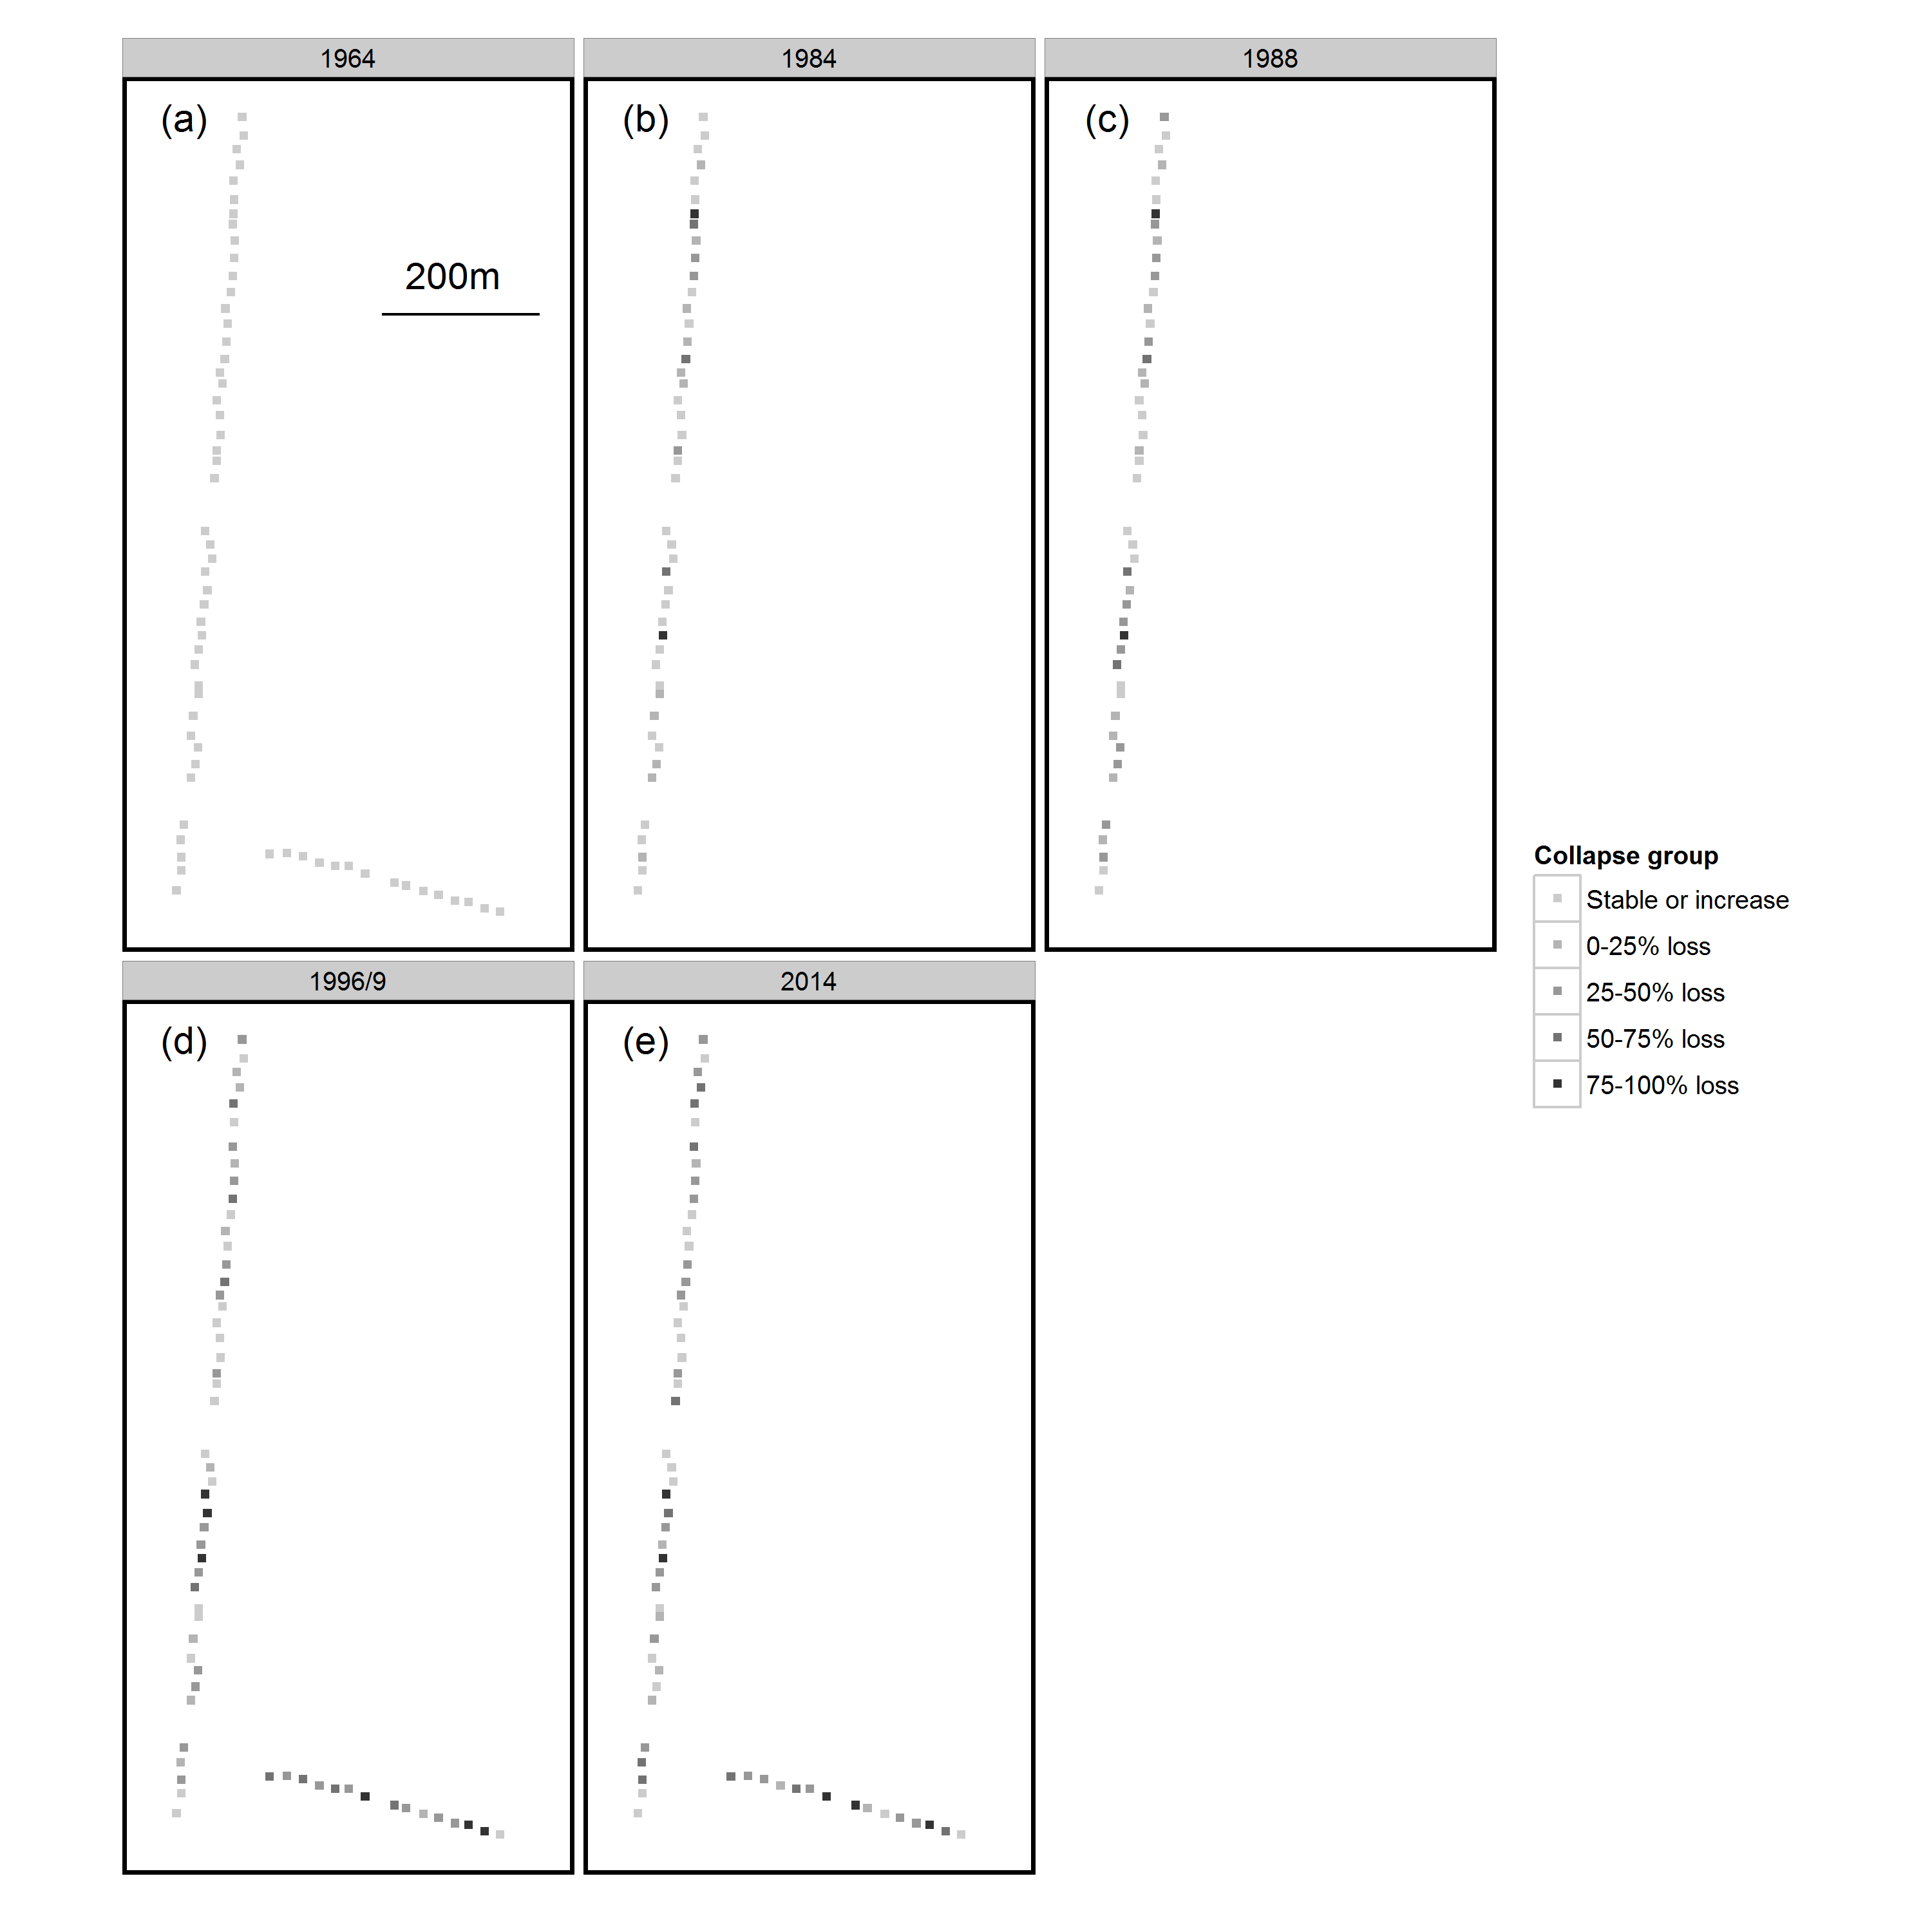

Figure S1 – Spatial distribution of plots at differing stages of collapse for the years (a) 1964, (b) 1984, (c) 1988, (d) 1996/9 and (e) 2014. Each square represents a 20 x 20m plot and the figure is to scale – see plot (a). Note that in 1984 and 1988 the shorter, unenclosed transect was not surveyed and hence is not shown for these years. The colour scale represents the changes in plot basal area and includes those that increased in basal area, and those that lost 0-25%, 25-50%, 50-75% and 75-100% of basal area

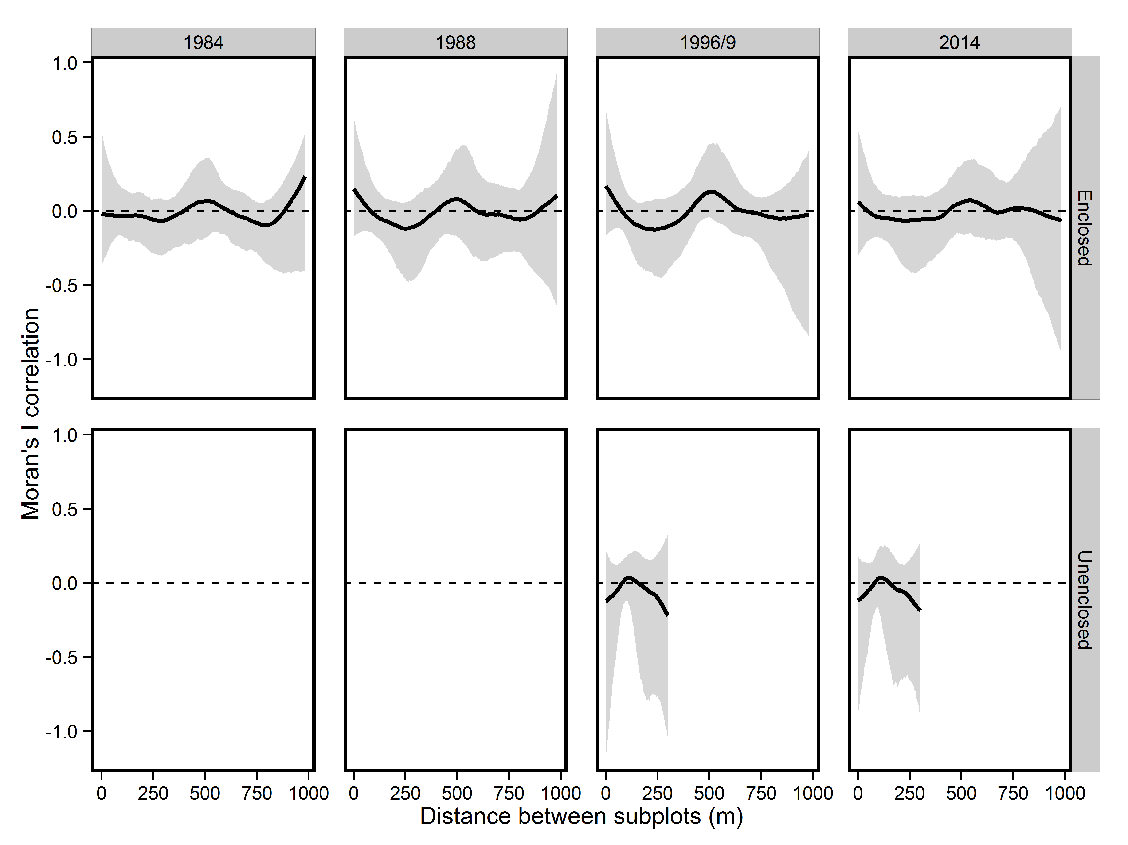

Figure S2 – Relationship between Moran’s I correlation for percentage decline in subplot BA and distance between subplots used in pairwise comparisons for both Enclosed and Unenclosed transects. Solid lines represent median bootstrapped correlations, and the grey shaded area the 95% confidence intervals for these correlations. The dashed line indicates where correlation was equal to zero. At no distance are pairwise correlations deemed to be significantly different from zero (α=0.05) since the grey shaded area overlap zero at all times.

Table S1 - Generalised linear mixed models considered for explanation of changes in subplot stem density and associated measures of parsimony (AICc), support (ΔAICc, AICc weight) and goodness of fit (Marginal R2)

|  |  |  |  |  |  |  |  |
| --- | --- | --- | --- | --- | --- | --- | --- |
| Y Variable | Model structure | df | Log likelihood | AICc | ΔAICc | AICc weight | Marginal R2 |
| Total stem density | Year*Collapse | 7 | -838.301 | 1691.024 | 0 | 0.98 | 0.37 |
| Year | 5 | -844.697 | 1699.619 | 8.59 | 0.01 | 0.31 |
| Year+Collapse | 6 | -844.502 | 1701.32 | 10.30 | <0.01 | 0.32 |
| Null model | 4 | -888.421 | 1784.992 | 93.97 | <0.01 | 0 |
| Collapse | 5 | -888.334 | 1786.893 | 95.87 | <0.01 | <0.01 |
| Stem density of trees >45 cm DBH | Year*Collapse | 5 | -210.001 | 430.519 | 0 | 1 | 0.214 |
| Year+Collapse | 4 | -218.823 | 445.988 | 15.469 | <0.001 | 0.073 |
| Collapse | 3 | -220.788 | 447.780 | 17.261 | <0.001 | 0.040 |
| Year | 3 | -221.053 | 448.310 | 17.791 | <0.001 | 0.037 |
| Null model | 2 | -223.018 | 450.137 | 19.618 | <0.001 | 0 |
| Stem density of trees with DBH 25-45 cm | Collapse | 3 | -222.685 | 451.574 | 0 | 0.558 | 0.144 |
| Collapse+Year | 4 | -222.214 | 452.771 | 1.197 | 0.307 | 0.147 |
| Collapse*Year | 5 | -221.979 | 454.474 | 2.901 | 0.131 | 0.146 |
| Null model | 2 | -229.092 | 462.285 | 10.711 | 0.003 | 0 |
| Year | 3 | -228.621 | 463.446 | 11.872 | 0.001 | 0.003 |
| Stem density of trees with DBH 15-25 cm | Collapse*Year | 5 | -251.932 | 514.381 | 0 | 0.423 | 0.124 |
| Collapse+Year | 4 | -253.216 | 514.774 | 0.393 | 0.348 | 0.109 |
| Collapse | 3 | -254.762 | 515.727 | 1.346 | 0.216 | 0.090 |
| Year | 3 | -258.000 | 522.204 | 7.823 | 0.008 | 0.019 |
| Null model | 2 | -259.545 | 523.191 | 8.810 | 0.005 | 0 |
| Stem density of trees with DBH 10-15 cm | Year | 3 | -243.417 | 493.038 | 0 | 0.422 | 0.280 |
| Year*Collapse | 5 | -241.292 | 493.100 | 0.063 | 0.409 | 0.307 |
| Year+Collapse | 4 | -243.261 | 494.863 | 1.825 | 0.169 | 0.283 |
| Null model | 2 | -283.497 | 571.094 | 78.058 | <0.001 | 0 |
| Collapse | 3 | -283.34 | 572.884 | 79.846 | <0.001 | 0.006 |
| Stem density of beech saplings | Collapse + Year | 4 | -149.444 | 307.309 | 0 | 0.403 | 0.310 |
| Collapse*Year | 5 | -148.553 | 307.744 | 0.436 | 0.324 | 0.314 |
| Year | 3 | -150.918 | 308.086 | 0.777 | 0.273 | 0.302 |
| Collapse | 3 | -215.043 | 436.336 | 129.027 | <0.001 | <0.001 |
| Null model | 2 | -216.474 | 437.071 | 129.763 | <0.001 | 0.000 |

Table S2 – Coefficient estimates for the most parsimonious model explaining changes in subplot stem density for the period 1964-2014, note that coefficients are in log units due to use of poisson generalised linear mixed models

|  |  |  |  |  |
| --- | --- | --- | --- | --- |
| **Y variable** | **Model Parameter** | **Estimate** | **SE** | **P value** |
| Total stem density | Intercept | 3.286 | 0.102 | <0.0001 |
| Collapsed | -0.015 | 0.128 | 0.91 |
| Year | -0.017 | 0.003 | <0.001 |
| Collapsed*Year | -0.012 | 0.003 | <0.001 |
| Stem density of trees >45 cm DBH | Intercept | 1.020 | 0.128 | <0.001 |
| Year | 0.320 | 0.168 | 0.057 |
| Collapse | 0.200 | 0.155 | 0.198 |
| Year*Collapse | -0.926 | 0.223 | <0.001 |
| Stem density of trees with DBH 25-45 cm | Intercept | 1.095 | 0.167 | <0.0001 |
| Collapse | -0.779 | 0.218 | <0.0001 |
| Year | -0.062 | 0.118 | 0.599 |
| Year*Collapse | 0.022 | 0.105 | 0.835 |
| Stem density of trees with DBH 15-25 cm | Intercept | 1.246 | 0.076 | <0.0001 |
| Year | -0.070 | 0.088 | 0.426 |
| Collapse | -0.446 | 0.113 | <0.001 |
| Year*Collapse | -0.136 | 0.172 | 0.429 |
| Stem density of trees with DBH 10-15 cm | Intercept | 1.252 | 0.030 | <0.0001 |
| Year | -0.931 | 0.148 | <0.001 |
| Collapse | -0.005 | 0.047 | 0.920 |
| Year*Collapse | -0.208 | 0.250 | 0.400 |
| Stem density of beech saplings | Intercept | 2.454 | 0.137 | <0.001 |
| Collapse | -1.426 | 0.98 | <0.001 |
| Year | 0.099 | 0.162 | 0.545 |
| Collapse*Year | -0.008 | 0.068 | 0.907 |

Table S3 - Generalised linear mixed models considered for explanation of changes as a result of forest dieback and associated measures of parsimony (AICc), support (ΔAICc, AICc weight) and goodness of fit (Marginal R2). CWM = community weighted mean

|  |  |  |  |  |  |  |  |
| --- | --- | --- | --- | --- | --- | --- | --- |
| **Y variable** | **Model structure** | **Degrees of freedom** | **Log likelihood** | **AICc** | **ΔAICc** | **AICc weight** | **Marginal R2** |
| Tree species richness | BA | 3 | -326.643 | 659.401 | 0 | 0.480 | 0.031 |
| BA+BA2 | 4 | -325.635 | 659.463 | 0.061 | 0.465 | 0.048 |
| Null model | 2 | -329.838 | 663.734 | 4.333 | 0.055 | 0 |
| Tree community composition | BA loss+BA loss2 | 8 | -108.801 | 234.311 | 0 | 1 | 0.47 |
| BA loss | 7 | -130.077 | 274.702 | 40.39 | <0.01 | 0.40 |
| Null model | 6 | -135.940 | 284.290 | 50.00 | <0.01 | 0 |
| Grass cover - Temporal | Year*Collapse | 8 | -284.812 | 586.757 | 0 | 0.99 | 0.44 |
| Year+Collapse | 6 | -291.873 | 596.398 | 9.641 | <0.01 | 0.40 |
| Year | 5 | -295.229 | 600.919 | 14.161 | <0.01 | 0.36 |
| Collapse | 4 | -327.115 | 662.535 | 75.778 | <0.01 | 0.05 |
| Null model | 3 | -330.798 | 667.779 | 81.021 | <0.01 | 0 |
| Grass cover - Gradient | BA+BA2+BA3 | 8 | -169.230 | 356.2 | 0 | 0.721 | 0.385 |
| BA+BA2 | 7 | -171.398 | 358.2 | 1.9 | 0.276 | 0.380 |
| BA | 6 | -176.957 | 366.9 | 10.7 | 0.003 | 0.327 |
| Null model | 5 | -181.262 | 373.2 | 17.0 | <0.001 | 0 |
| Bracken cover | Null model | 3 | 27.973 | -49.668 | 0 | 0.842 | 0 |
| BA | 4 | 26.937 | -45.403 | 4.264 | 0.100 | 0.014 |
| BA+BA2+BA3 | 6 | 28.301 | -43.591 | 6.077 | 0.040 | 0.031 |
| BA+BA2 | 5 | 26.327 | -41.941 | 7.727 | 0.018 | 0.019 |
| Ground flora species richness | BA+BA2 | 4 | -222.095 | 452.677 | 0 | 0.682 | 0.136 |
| BA+BA2+BA3 | 5 | -222.063 | 454.867 | 2.190 | 0.228 | 0.135 |
| BA | 3 | -225.593 | 457.476 | 4.798 | 0.062 | 0.057 |
| Null model | 2 | -227.447 | 459.037 | 6.360 | 0.028 | 0 |

Table S4 - Coefficient estimates for the most parsimonious models explaining changes in subplot biodiversity as a result of forest dieback

|  |  |  |  |  |
| --- | --- | --- | --- | --- |
| **Y Variable** | **Model Parameter** | **Estimate** | **SE** | **P value** |
| Tree species richness | Intercept | 1.039 | 0.049 | <0.0001 |
| BA loss since 1964 | -0.284 | 0.108 | 0.009 |
| BA loss since 19642 | -0.083 | 0.104 | 0.428 |
| Tree community composition | Intercept | 1.255 | 0.201 | <0.001 |
| BA loss | 1.453 | 0.137 | <0.001 |
| BA loss2 | -0.763 | 0.101 | <0.001 |
| Grass cover – Temporal | Intercept | -5.324 | 0.455 | <0.001 |
| 1996 | 2.426 | 0.555 | <0.001 |
| 2014 | 2.106 | 0.555 | <0.001 |
| Collapse | -0.289 | 0.617 | 0.640 |
| 1996*Collapse | 1.967 | 0.748 | 0.009 |
| 2014*Collapse | 2.495 | 0.748 | <0.001 |
| Grass cover - Gradient | Intercept | -2.6180 | 0.2633 | <0.001 |
| Loss in BA since 1964 | 1.8238 | 0.8158 | 0.0276 |
| Loss in BA since 19642 | 3.4729 | 2.2121 | 0.122 |
| Loss in BA since 19643 | 0.7975 | 2.546 | 0.783 |
| Bracken cover | Intercept | 0.107 | 0.043 | 0.014 |
| BA | 0.033 | 0.101 | 0.749 |
| BA2 | 0.295 | 0.253 | 0.247 |
| BA3 | 0.430 | 0.373 | 0.252 |
| Ground flora species richness | Intercept | 1.903 | 0.079 | <0.001 |
| Loss in BA since 1964 | -0.027 | 0.239 | 0.912 |
| Loss in BA since 19642 | 1.03402 | 0.369 | 0.006 |

**References**

Dingman, S.L. (2002) *Physical hydrology*. Prentice Hall, Upper Saddle River, NJ.

Hamon, W.R. (1963) Computation of direct runoff amounts from storm rainfall. *International Association of Scientific Hydrology Publication,* **63**,52-62.

McCune, B. & Keon, D. (2002) Equations for potential annual direct incident radiation and heat load. *Journal of Vegetation Science,* **13**, 603-606.

Stephenson, N.L. (1998) Actual evapotranspiration and deficit: biologically meaningful correlates of vegetation distribution across spatial scales. *Journal of Biogeography*, **25**, 855-870.

Thornthwaite, C.W. (1948) An approach towards a rational classification of climate. *Geographical Review*, **38**, 55-102.

Thornthwaite, C.W. & Mather, J.R. (1955) The water balance. *Publications in Climatology*, **8**, 1-104.

Thornthwaite, C.W., Mather, J.R. & Carter, D.B. (1957) Instructions and tables for computing potential evapotranspiration and the water balanace. *Publications in Climatology*, **10**, 181-311.

Willmott, C. J., Rowe, C.M. & Mintz, Y. (1985) Climatology of the terrestrial seasonal water cycle. *Journal of Climatology*, **5**, 589-606